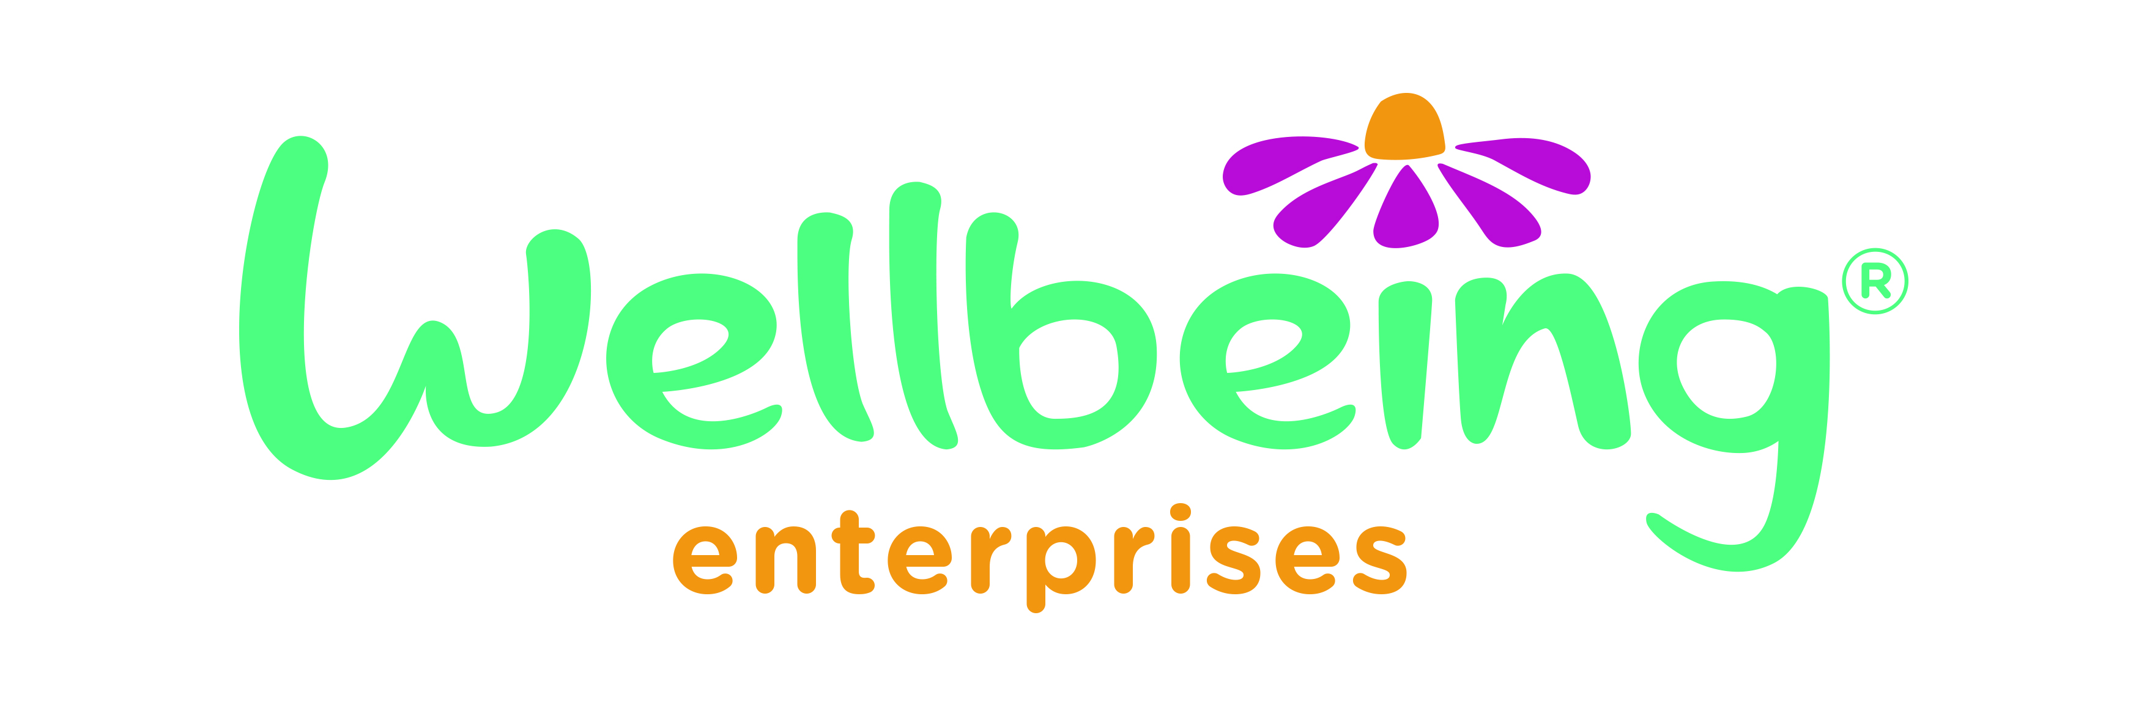 Halton Summer Wellbeing Fund

A: Contact details

- Personal details

First name: | Surname:
Address:

Postcode: | Mobile:
Phone number: | Email address:

2. Are you applying on behalf of an organisation or group? (please tick)
Y |  | N

3. If yes please state name:

4. Who will benefit as a result of your activities? (tick all that apply)
 | Children and families |  | People with high risk behaviours
 | Young people |  | Communities
 | Adults in need |  | People with disabilities
 | Older people |  | Asylum seekers
 | BAME communities |  | Other- please specify

B: About Your Project

5. What is your project called?

6. Please describe your project. How will you ensure it complies with Covid-19 guidance?
maximum 350 words

7. What is the need for this project?
maximum 200 words

8. What wellbeing outcomes do you aim to achieve with the project?
maximum 200 words

D: Support

9. What is the total cost of your project?

10. Please detail your proposed expenditure in the table below
Item of Expenditure | Cost
TOTAL

11. Over what time frame will your project run?

From: |  | Until:

12. References
Please provide the names and addresses of two referees. Referees should know you and support your project idea and your group / organisation if you are a part of one. References may include people who have an important position in the community like a teacher or a community worker for example.
Referee 1

First name: | Surname:
Job title:
How do you know this person:

Address and postcode:
Contact number: |  | Email:

Referee 2
First name: | Surname:
Job title:
How do you know this person:
Address and postcode:
Contact number: |  | Email:

Your signature
I confirm that, as far as I know, all the information provided on this application form is true and correct. I understand that I may be asked for more information at any stage of the application process or when the project is running.

Your signature: | Date:

Please return to info@wellbeingenterprises.org.uk or post to Wellbeing Enterprises, Bridgewater House, Old Coach Road, Runcorn, WA7 1QT by 5:00pm Sunday 1st August 2021

